Circuit Board Diagram
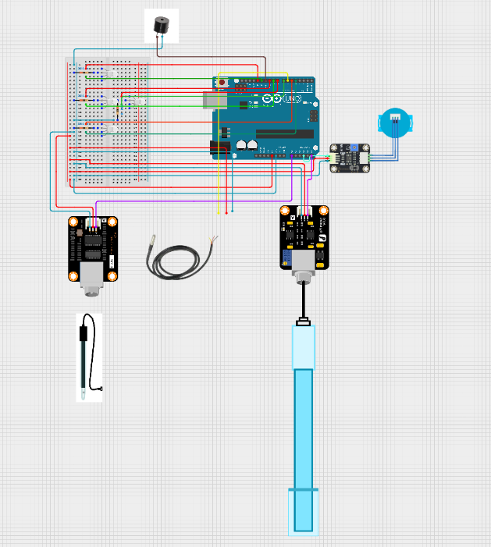Sensors:
- Analog pH Meter (SEN0161)
- Turbidity Sensor (SEN0189)
- Waterproof DS18B20 Digital Temperature Sensor (DFR0198)
- Analog EC Sensor (DFR0300-V2)

Code
//Thermometer
#include <OneWire.h>
#include <DallasTemperature.h>

#define ONE_WIRE_BUS 6

OneWire oneWire(ONE_WIRE_BUS);

DallasTemperature sensors(&oneWire);

float Celcius = 0;
float Fahrenheit = 0;

//Turbidity sensor
int turbiditySensorPin = A3;

//pH sensor
#define PH_PIN A5
float voltagePh,phValue;
#include "DFRobot_PH.h"
DFRobot_PH ph;

//EC sensor
#include "DFRobot_EC.h"
#include <EEPROM.h>

#define EC_PIN A0
float voltage, ecValue = 25;
DFRobot_EC ec;

//RGB Led
int turbidityR = 13;
int turbidityG = 12;

int temperatureR = 10;
int temperatureG = 9;

int ecR = 8;
int ecG = 7;

int phR = 5;
int phG = 4;

int buzzerPin = 11;

void setup() {
ec.begin();
sensors.begin();
Serial.begin(115200);
ph.begin();
pinMode(turbidityR , OUTPUT);
pinMode(turbidityG , OUTPUT);
pinMode(temperatureR , OUTPUT);
pinMode(temperatureG , OUTPUT);
pinMode(phR , OUTPUT);
pinMode(phG , OUTPUT);
pinMode(ecR, OUTPUT);
pinMode(ecG, OUTPUT);
pinMode(buzzerPin , OUTPUT);
}

void loop() {

//Temperature sensor
sensors.requestTemperatures();

Celcius = sensors.getTempCByIndex(0);

//Turbidity sensor
int turbiditySensorValue = analogRead(turbiditySensorPin);
int turbidity = map(turbiditySensorValue, 0,640, 100, 0); //check if sensor output is 1023 or 640

//Ph sensor
voltagePh = analogRead(PH_PIN) * (5.0 / 1023.0);

//phValue = 7.0 - (voltage - 2.5) / 0.18;
phValue = ph.readPH(voltagePh, Celcius);

//EC sensor
voltage = analogRead(EC_PIN)/1023.0*5000;
ecValue = ec.readEC(voltage,Celcius)*1000;

//Temperature RGB and buzzer
if(Celcius > 10 && Celcius < 20){
digitalWrite(temperatureR , 0);
digitalWrite(temperatureG , 1);
digitalWrite(buzzerPin , 0);
}else if(Celcius >= 5 && Celcius <= 10){
digitalWrite(temperatureR , 1);
digitalWrite(temperatureG , 1);
digitalWrite(buzzerPin , 0);
}else if(Celcius >= 20 && Celcius <= 25){
digitalWrite(temperatureR , 1);
digitalWrite(temperatureG , 1);
digitalWrite(buzzerPin , 0);
}else if(Celcius > 25 || Celcius < 5){
digitalWrite(temperatureR , 1);
digitalWrite(temperatureG , 0);
digitalWrite(buzzerPin , 1);
}

//pH RGB and buzzer
if(phValue > 7.0 && phValue < 8.5){
digitalWrite(phR , 0);
digitalWrite(phG , 1);
digitalWrite(buzzerPin , 0);
}else if(phValue >= 6.5 && phValue <= 7.0){
digitalWrite(phR , 1);
digitalWrite(phG , 1);
digitalWrite(buzzerPin , 0);
}else if(phValue >= 8.5 && phValue <= 9.0){
digitalWrite(phR , 1);
digitalWrite(phG , 1);
digitalWrite(buzzerPin , 0);
}else if(phValue > 9.0 || phValue < 6.5){
digitalWrite(phR , 1);
digitalWrite(phG , 0);
digitalWrite(buzzerPin , 1);
}

//Turbidity
if(turbidity < 4){
digitalWrite(turbidityR , 0);
digitalWrite(turbidityG , 1);
digitalWrite(buzzerPin , 0);
}else if(turbidity >= 4 && turbidity <= 5){
digitalWrite(turbidityR , 1);
digitalWrite(turbidityG , 1);
digitalWrite(buzzerPin , 0);
}else if(turbidity > 5){
digitalWrite(turbidityR , 1);
digitalWrite(turbidityG , 0);
digitalWrite(buzzerPin , 1);
}

//EC sensor
if(ecValue > 200 && ecValue < 750){
digitalWrite(ecR , 0);
digitalWrite(ecG , 1);
digitalWrite(buzzerPin , 0);
}else if(ecValue >= 150 && ecValue <= 200){
digitalWrite(ecR , 1);
digitalWrite(ecG , 1);
digitalWrite(buzzerPin , 0);
}else if(ecValue >= 750 && ecValue <= 800){
digitalWrite(ecR , 1);
digitalWrite(ecG , 1);
digitalWrite(buzzerPin , 0);
}else if(ecValue > 800 || ecValue < 150){
digitalWrite(ecR , 1);
digitalWrite(ecG , 0);
digitalWrite(buzzerPin , 1);
}

Serial.print(Celsius);
Serial.print(",");
Serial.print(turbidity);
Serial.print(",");
Serial.print(phValue);
Serial.print(",");
Serial.println(ecValue);

delay(500);
}

